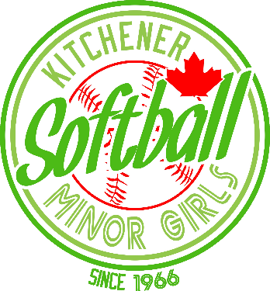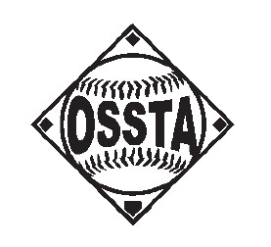

OSSTA Girls Tournament Entry Form
Thank you for your interest in the KW select tournaments for 2023!

We are running two tournaments this year.

U17 - Bantam on Saturday June 15, 2024 $500 Members $550 Non Members
U21 - Midget on Sunday June 16, 2024 $500 Members $550 Non Members

Please complete the application form below and email it to Sean Richardson at houseleague.kmgsa.com.

For electronic EMT payments please send your payment to registrations@kmgsa.com with the password of “kmgsa1” and be sure to include your division and team name in the message.

Association Name __________________________________________________________________

Division
☐ U17 - Bantam (Saturday June 15, 2024)
☐ U21 - Midget (Sunday June 16, 2024)

OSSTA #__________________________________________________________________

Coach Name: ___________________________________

E-Mail: __________________________________

Address: __________________________________

Phone: _______________________

Only when Final Roster, Proof of Insurance Form, verified payment and Application are received by KMGSA, will a team be officially deemed as registered. Tournament spots are done in order of fully registered teams.

If mailing documents, please mail to:

Kitchener Minor Girls Softball Association,
330 Gage Ave #4, Kitchener, ON N2M 5C6

All teams are guaranteed 3 games (weather permitting).

Any changes to your OSSTA submitted roster must be submitted to houseleague@kmgsa.com and OSSTA one week prior to the tournament and must include details as to why the removal/addition of players. Any modified rosters must be approved prior to the start of the tournament.

All players and coaches are required to sign in at the start of the tournament and have your bats inspected and marked. Bats that are not approved are not allowed near the diamonds (must be left in your car). Score sheets must have player numbers beside the player’s name.

Each player needs to be able to show proof of identity including date of birth, if asked, or they will not be allowed to play.

No new innings to start after 90 minutes.
Round Robin scoring will be 2 points for a win, 1 point for a tie. If the home team is leading in the bottom of the last inning, the game is over and the home team will NOT bat.

In the event of a tie in the standing the following will be used to determine ranking.
- Head to Head Game results
- Runs for/Against differential to a maximum of 7 runs per game
- Runs allowed / innings played
- Runs scored / innings played

Acceptable Bat Certification Stamps:
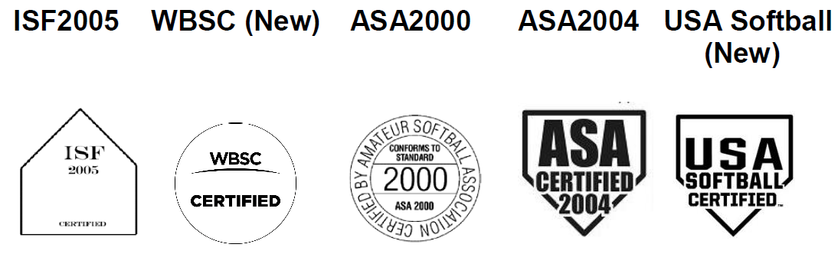
- Any bat that appears on the WBSC Softball Approved Bat List and has a current ISF certification stamp (2005 only) will be accepted for play at a Softball Canada event or,
- Any bat that appears on the USA Softball Approved Bat List and has an ASA 2000 or 2004 certification stamp will also be accepted for play at a Softball Canada event.
- The bat must meet the compression standards outlined by the certifying organization and may be tested to ensure they are in the proper range.
- The bat must still pass a visual inspection per the current Softball Canada rulebook.

